**JDBC 11 june**

**IN BETWEEN 700 AND 900**

FindIterable<Document> documents = collection.find(Filters.*and*(

Filters.*gte*("price", 700),

Filters.*lte*("price", 900)

));

for (Document document : documents) {

System.*out*.println(document);

}

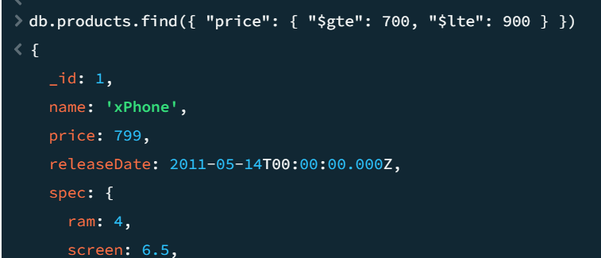

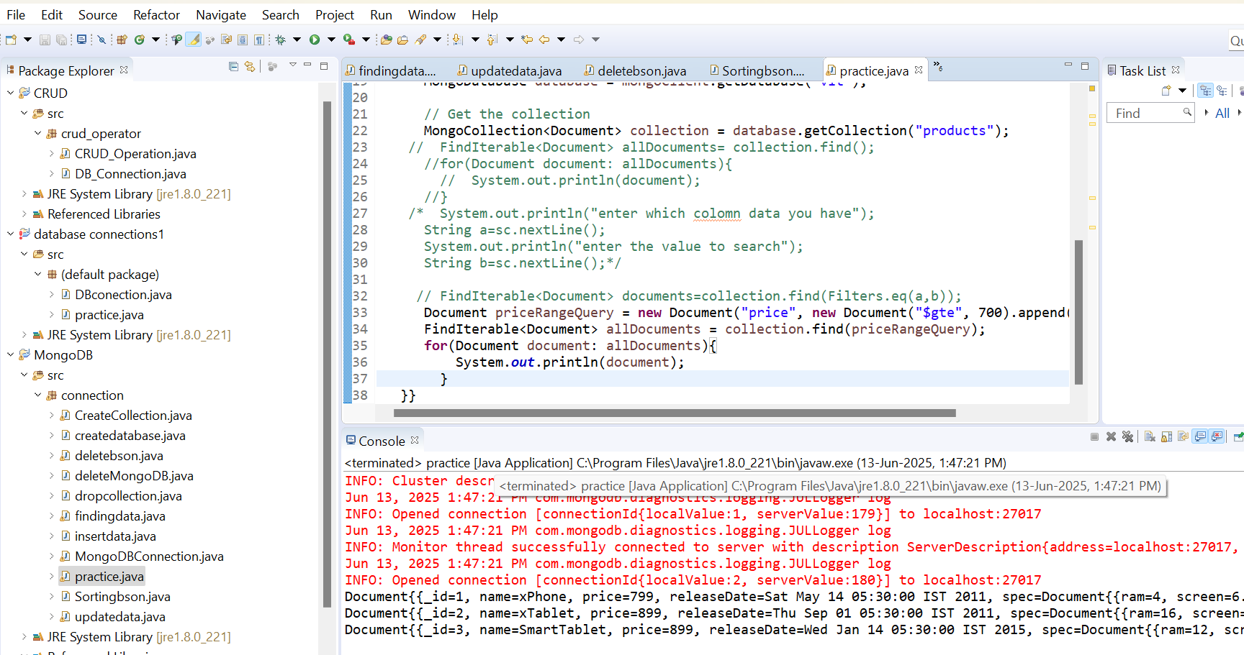

**AVERAGE PRICE**

AggregateIterable<Document> result = collection.aggregate(Arrays.*asList*(

Aggregates.*group*(**null**, Accumulators.*avg*("avgPrice", "$price"))

));

// Fetch and print the result

Document avgDocument = result.first();

**if** (avgDocument != **null**) {

System.***out***.println("Average Price: " + avgDocument.getDouble("avgPrice"));

} **else** {

System.***out***.println("No data found in the collection.");

}

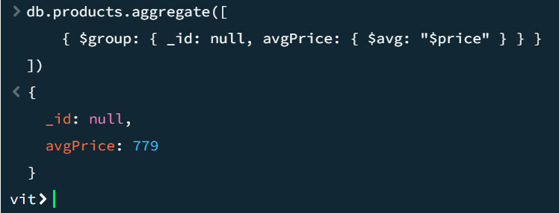

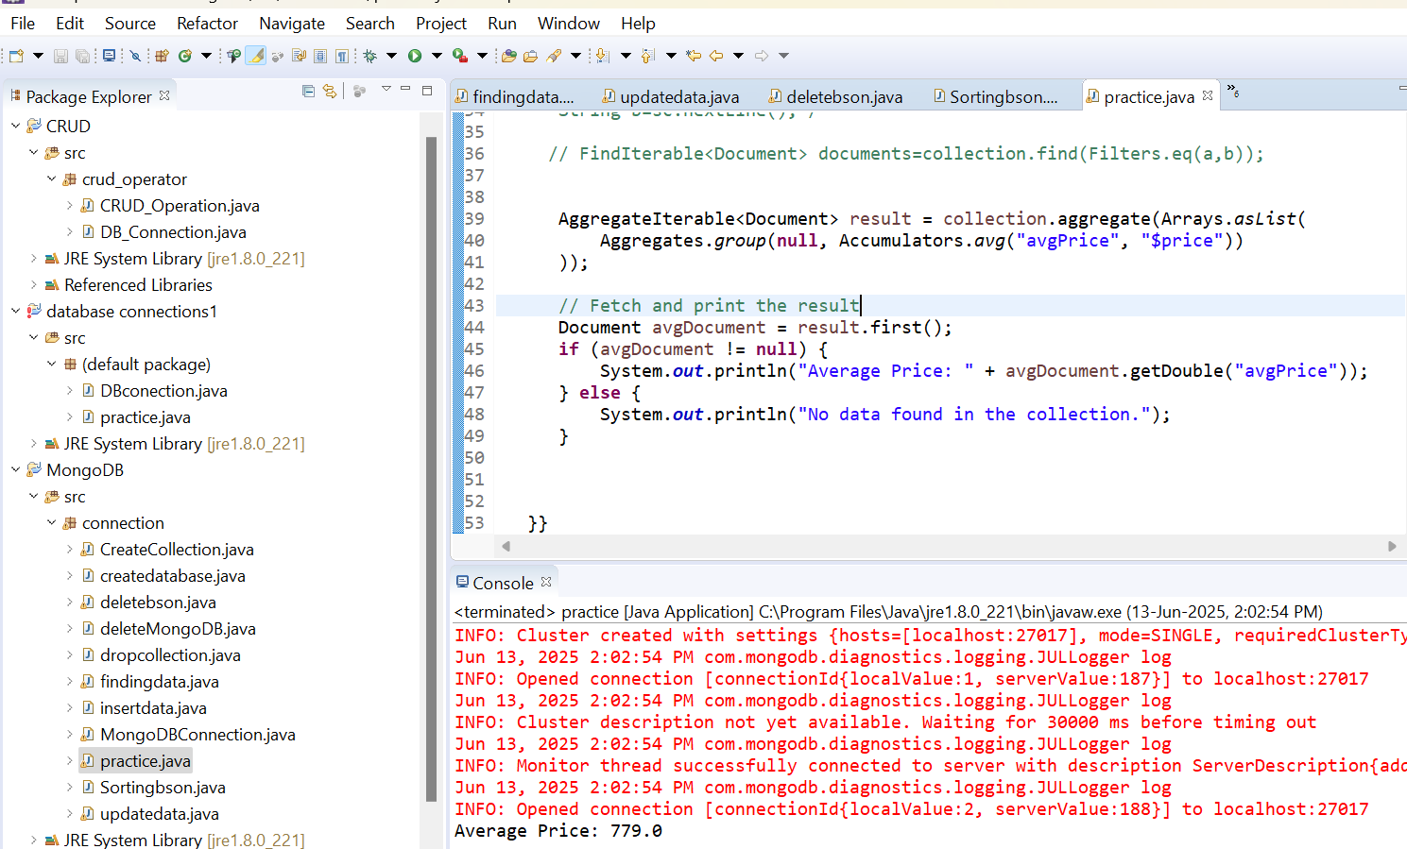

**MAXIMUM PRICE IN EVERY ITEM**

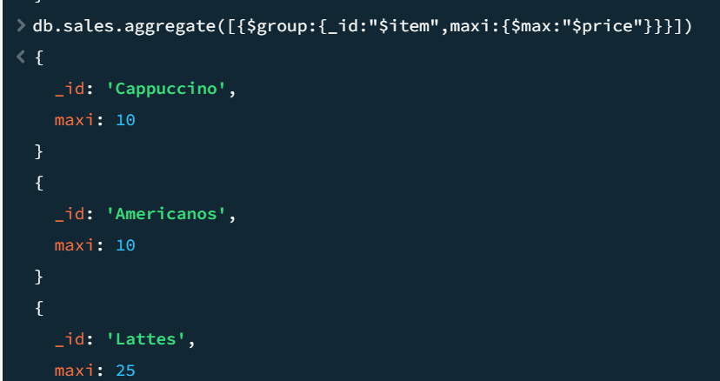

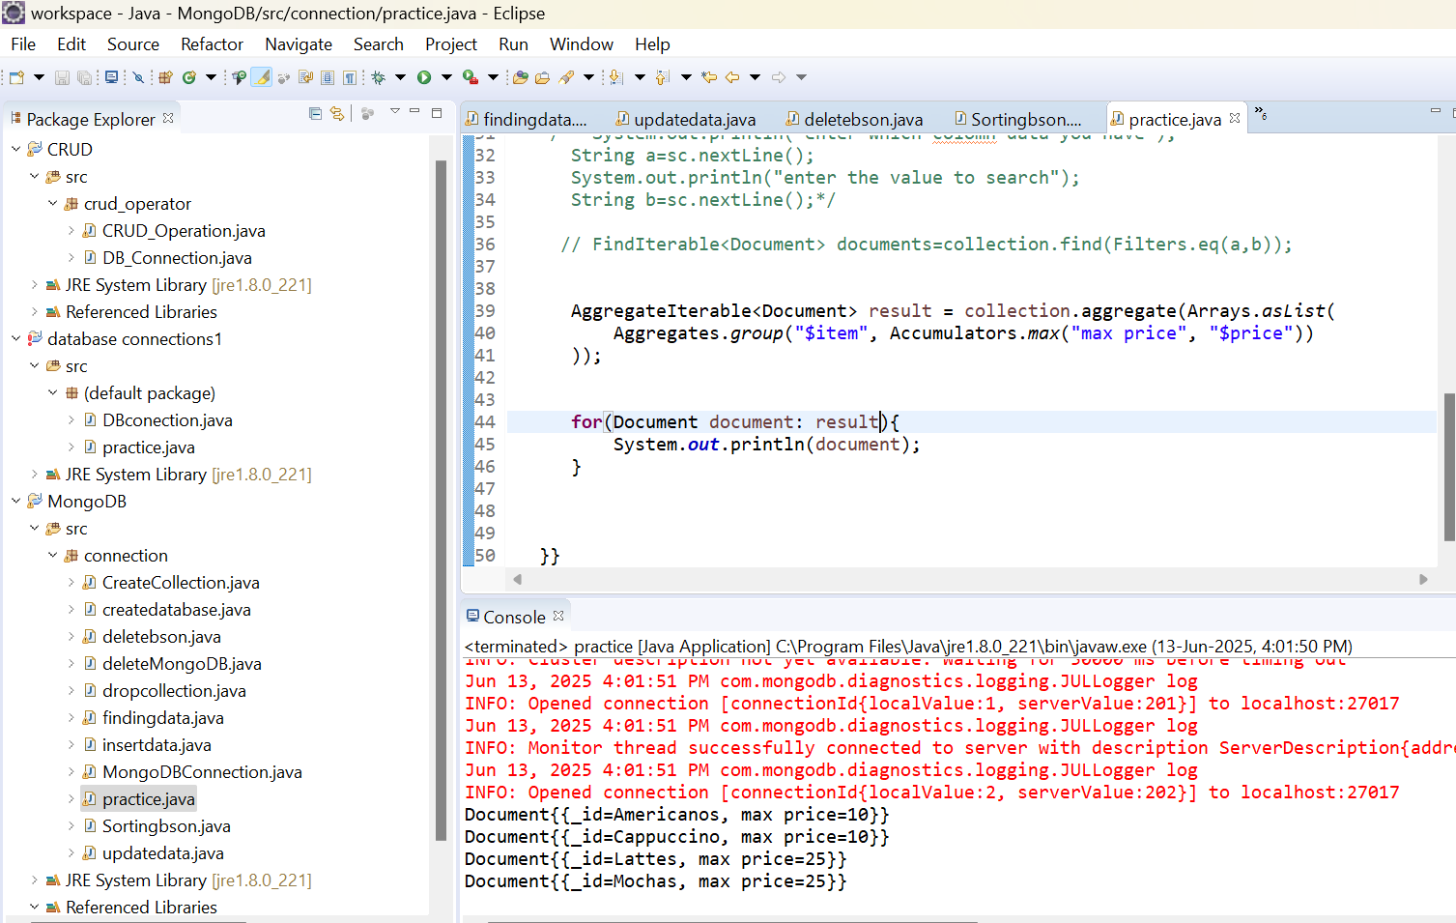

AggregateIterable<Document> result = collection.aggregate(Arrays.*asList*(

Aggregates.*group*("$item", Accumulators.*max*("max price", "$price"))

));

**for**(Document document: result){

System.***out***.println(document);

}